**EXPERIMENT 7**

**DQL COMMANDS (COLLEGE SCHEMA)**

**Aim:**

* Display student id and marks from the student table.
* Display faculty id and name from the faculty table.
* Display who got grade A.
* Display whose marks are greater than 70.
* Display the female students whose marks are greater than 85.
* Delete the failed students.
* Display activity id and name using object.
* Display student id, faculty id using course name condition with object.
* Select department name starting from ‘c’ and faculty name ending with ‘ ’.
* Select activity having characters between ‘ck’.
* Group by faculty id and display.
* Display the students list whose grade is A using having.
* Display the faculty list who are teaching PPS.
* Apply aggregate functions in student marks - max, min, sum, count, avg.

O19.png

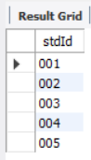 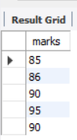

O22.png

